Jaya Surya Ramisetty

Tuneflix: Music Application

# Abstract

TuneFlix is a concept in music streaming mobile application that can redesign the way people interact with music and artists they love. Differently from conventional platforms, TuneFlix promotes users’ engagement, providing some of three key features, such as—playlist generation, channels by user, artist-user interaction. While the use of the Spring Boot as a base framework and Hibernate for implementing business logic, along with Spring Security for authorization and access control, provides data security to its users along with a robust technical framework. In this perspective, TuneFlix outlines a ‘bottom-up’ approach of interface design where users are given freedom in their musical selection and can freely and actively share with like-minded people from within the new community. As developed in this paper, TuneFlix could pose a competitive threat to conventional platforms of music streaming due to its ability to give users of the application more control and artists who appear in the platform as well the core problem areas that hinder the scalability of the application and data privacy. However, the platform holds great potential to positively reshape the experience of consuming digital music registered in the growing music streaming market which will be safe, ethical, and oriented to the user.

***Keywords:*** Music streaming, personalized playlists, artist-user interaction, Spring Boot, Hibernate, user engagement, music application, web development, TuneFlix.

Table of Contents

Abstract 2

1 Introduction 5

1.1 Research questions 10

2 Literature Review 11

3 Methodology 17

3.1 Research Design 17

3.2 Application Development Approach 18

3.3 Requirements Analysis 18

3.4 Design Phase 18

3.5 Use Case Diagram 19

3.6 Data Flow Diagram 20

3.7 Development 20

3.8 Ethical Considerations 21

3.9 Limitations 21

4 Results and Discussion 22

4.1 Discussion 27

5 Conclusion 29

6 Future Directions 31

7 References 33

**List of Figures**

Figure 1 Use Case Diagram 19

Figure 2 Data Flow Diagram 20

Figure 3 Home Page 22

Figure 4 Singer Management 23

Figure 5 Playlist Management 24

Figure 6 Channel Creation 25

Figure 7 User Management 26

# Introduction

Music streaming services have become the new way people engage with content and consumer music, changing the industry from buying physical and digital copies of tracks to streaming. This is because the current dominant giants in the market include Spotify, Apple Music, and YouTube Music which provide an immense collection of songs and other music related content alongside various options to personalize the experience (Park & Kaneshiro, 2021). While there are a myriad of options, certain aspects like customized playlists as well as interactions between artists and users are underexplored, even though they are vital in increasing the satisfaction and activity of the users (Rizki Bagaswara Putra & Setiawan, 2022). TuneFlix, a music streaming application, is planned to solve this problem with using these features and user and artist modules and utilizing Spring Boot, Hibernate, and Spring Security frameworks. This work seeks to establish the importance of tailored content and the interactions between musicians and users and their role in the overall use and engagement in music streaming applications.

Over the past few years, music streaming services have rapidly expanded due to the availability of improved technologies and the need to have a personalized music playlist (Skutle, 2022). The features of the application and services that have become crucial for users’ retention include playlist creation, music suggestions for users, and interaction between artists and fans. However, many of these platforms seldom have a clear roadmap on how to fully harness the potential of these features (Weinberger & Bouhnik, 2020). Although the technological infrastructures of these platforms are complex, how users engage with the playlists and how they engage with artists is not fully understood. TuneFlix uses recent technologies including Spring Boot for developing the application, Hibernate for managing data, and Spring Security for secure user interactions. Through the information gathered in TuneFlix’s user and artist modules, this study offers a detailed discussion of the specific features that affect satisfaction due to customization and interaction.

Music streaming platforms have changed how users interact with the media, providing access to vast libraries, customization options, and glow tips interaction options. Most platforms have achieved the provision of a vast number of items with various elements that make up users' satisfaction and engagement, and the roles that personalized playlists and interactions between artists and users play in the process receive inadequate attention. These elements are crucial in the current era of cutthroat competition to retain and satisfy customers using online services (Weinberger & Bouhnik, 2020). TuneFlix, a music streaming application developed with the help of Spring Boot, Hibernate, and Spring Security, consists of crucial User Modules, Singer Modules, and Playlist management systems to enhance the application's functionality. Although there is no shortage of choices for the users, empirical evidence is scarce regarding the relationship between the personalized playlists created based on user preferences of direct artist-user communications and the behavioral patterns of the users. In this respect, this study will seek to concentrate on these features to fill this knowledge gap and help understand how such interactions and personalized content generate utility and user satisfaction in the context of music streaming applications.

Besides, this study will also examine how application frameworks such as Spring Boot and Hibernate enable these functionalities, thus offering cohesive experiences from the user and artist perspectives. Thus, one can pinpoint the lack of definition for personalization, interaction, and engagement as one of the primary threats to streaming platforms, which might give up competitiveness and, consequently, lose clients or users. Therefore, this study will aim to develop an in-depth analysis of these crucial factors so that developers, designers, and other music streaming industry stakeholders can develop pleasing interfaces that appeal to users.

This research addresses a lack of attention to the micro-level aspects of music streaming services centered on playlist personalization and artist-fan relations. Although work in this domain reveals valuable knowledge about the general user activities, content consumption, and the technological architecture of streaming services, research on more in-depth analyses of particular attributes like playlist and artist-to-user communication is sparse. Modern studies fail to incorporate user preferences and interactions from the user's and artist's standpoint. The experience of using the TuneFlix web application developed with the help of Spring Boot, Hibernate, and Spring Security will shed light on these dynamics (Weinberger & Bouhnik, 2020). The app will include features such as creating channels, uploading songs, creating playlists, and users' ability to interact with artists. This work will investigate how incorporating personalized playlist features based on algorithms that provide content based on users' preferences and direct communication with Singer Modules, with which the artist can communicate, improves general usability.

In addition, the study will analyze how these features will pay much attention to how Spring Boot and Hibernate handle complex data operations and how user administration is secured. One of the main advantages of the presented research is the equal focus on UX design and the system level. It narrows the gap between UX design and development since it offers the developer practical solutions to incorporate these features to enhance users' satisfaction on music streaming platforms.

The study's relevance to the academic world is based on its capacity to inform future development models of music streaming platforms regarding the users' preferences and approach towards the application. Customization has remained one of the significant measures used in online services, especially in music streaming, as it contains the user's desired content according to their state. This paper will contribute to TuneFlix and other similar platforms by establishing how personalized playlists affect users' engagement to guide on assorted strategies that can be implemented to improve personalized services and, ultimately, the level of engagement and satisfaction among users. The question of artists' interactions with the users is also significant. As there is a growing trend of artists seeking direct communication with the audience, this research will assess how these interactions through the Singer Module translate to the user's level of satisfaction.

Music consumption on platforms with strong bonds with consumers and artists can lead to higher listening hours, more consumers, and a lesser rate of churn. Further, it is even more crucial regarding the technical aspect of TuneFlix: the application is built using Spring Boot, Hibernate, and Spring Security. It will also help understand the users' behavior and how these technologies can be better embraced to design secure, scalable, efficient systems capable of delivering personalized content and supporting user interactions. The results from this research can aid in improving current and creating novel attributes in future platforms since the music streaming market is still rapidly developing. Lastly, this work establishes the strategic importance of user-centered features in sustaining users' loyalty and satisfaction within music streaming apps.

This study is significant because it addresses a critical but often overlooked area of music streaming: to examine the effects of personalized playlists and user artist interactions on engagement and satisfaction of the users. While prior research has investigated broad user behaviour, content watch, and technology related factors, there is a lack of research on the specific factors that influence the user engagement in streaming services. In light of these features, based on the concept of TuneFlix, this study extends the understanding of how streaming service media can be developed in Furthermore, the study also offers a technical viewpoint as to how platforms such as Spring Boot and Hibernate may enhance the functionality and security of platforms to the advantage of the user and the developer.

Previous research about music streaming services mainly focuses on consumption behavior of users, technological aspects of these services, and business models (Moysis et al., 2023). Nevertheless, the existing literature lacks specific focus on the functionality of the features like playlisting and artist user interaction (Jansson, 2021). Few studies analyze in detail how engagement is affected by features such as recommendation or direct communication between artists and their fans (NG et al., 2021). Also, there is scarce literature on how application frameworks such as Spring Boot and Hibernate can enhance user experiences in music applications, which makes this research relevant and timely.

The first research question of this work is how to increase the engagement and satisfaction of the users of music streaming applications through personalized playlists and direct interactions between artists and users. In particular, the study aims to:

1. To understand the impact of personalized playlists on user engagement, consider user preferences and the processes that underpin the creation of custom content.
2. Examine the effects of direct artist-user interaction on user satisfaction with emphasis on the communication channel via the Singer Module.
3. Review how Spring Boot, Hibernate, and Spring Security support this by providing tools for custom and engaging functionalities that do not compromise user experience.
4. **Provide practical insights for developers and designers** of music streaming platforms, offering recommendations on how to implement these features to maximize user retention and satisfaction.

Through these objectives, the study will contribute to both the academic understanding of user engagement in digital media and the practical development of more user-centered music streaming platforms.

## Research questions

1. How do personalized playlists influence user engagement in music streaming apps?
2. What effect does direct artist-user interaction have on user satisfaction in music apps?

# Literature Review

The development of music streaming services has revolutionized how people listen to songs, and more so, they shift from a model of ownership of the music they need to download. Applications like Spotify, Apple Music, and YouTube Music are now giants that allow users to use vast libraries of content where they can easily listen to their favorite music anytime and wherever they want. More and more streaming services are switching from pay-per-song or pay-per-album to subscription-based services that grant users access to massive music libraries, thereby heralding changes in an industry that could be considered ripe for disruption (Dolata, 2020).

Growths in cloud computing, storage, and distribution systems have ensured that these services offer fast and efficient access to music internationally. The advantage of one-click TV streaming compared to earlier forms of entertainment such as CD or even MP3 downloads has been a major driving factor behind it. Several artists freely perform with their eclectic music available online, thus eliminating the constraints that record labels used to present to independent artists.

Streaming platforms have also benefited from algorithms in machine learning, especially in enhancing customers' experiences by recommending products best suited for them. This makes these platforms attractive since they determine users' behavior in coming up with desired playlists to make them stick to the apps. Although moving to streaming offers significant advantages, platforms must always develop new ways for people's engagement (Spilker & Colbjørnsen, 2020).

One of the key elements that led to the accomplishment of music streaming platforms is the level of engagement of users. It concerns how platforms deliberately retain users in the long run. One of the key strategies to encourage users to spend more time is the automated recommendation of music according to the user's activity. More generally, products generated through the analysis of users' listening habits alleviate the problem of information overload, i.e., the production of playlists based on user preferences, which enables listeners to navigate large amounts of content. Engagement is easily maintained through personalization to the user, continuously giving the listener a personalized session with the platform (Hesmondhalgh, 2020).

These systems use the data provided by the users, such as listening history and behavior, to select appealing and good music. However, as much as specific recommendations increase the immediate satisfaction of the user, this raises the issue of how effective they are in the long run. Users may at first see the value of recommendations based on past performance and choice, but as a result of low risk, these swiftly become repetitive. This is because subscription and continued patronage of the services require sustaining innovation on the recommendation algorithms to hold interest in the changing user base. To make users as active as possible, several recommendation systems are presented to be optimized repeatedly (Spilker & Colbjørnsen, 2020).

Besides offering the content, effective interaction between artists and users appears to be another key factor influencing user engagement. Convention modes of conveying music pit artists against fans at concerts, dances, person-to-person encounters, and other similar features. Sadly, the vivid stream is changing their interaction, where they deal with the platform itself, not with the artists themselves (Prey, 2020). Product platforms that foster artist-user interfaces hold the capacity to create deeper bonds between fans and artists, leading to increased loyalty. The tools include curated playlists by artists or artists releasing something new on a streaming service. However, these tools are not building deeper ways for artists to engage directly with users, which is becoming another major area where platforms can differentiate themselves. Enabling artists to share information with their fans, providing fans with information about them and their music, or even responding to information from fans improves user experience. Such an engagement level is useful in retaining the user and, at the same time, creating a strong bond between the artists and their fans. Platforms that successfully integrate these interactions can create a more community-driven and engaged user environment (M et al., 2021).

It is important and necessary for the backend systems of music streaming platforms to be properly designed to match their performance, scalability, and security. Some of the extensively used technologies in streaming web applications are Spring Boot, Hibernate, and Spring Security, which provide velocity and security and make it more competent to get a good stream (Bresciani et al., 2021). In the context of how it is helpful, Spring Boot provides a full-stack framework that combines many of the parts required for big-scale platforms and applications. Its ability to deal well with configuration, which makes it possible to set up the application rapidly, makes it suitable for rapid development and then production. Additionally, integration is made easier through Spring Boot for microservices, which allows scaling up different parts of an application independently while maintaining high performance during high user loads (Singh et al., 2021).

Hibernate is another object-relational mapping (ORM) tool that handles relationships between various data on this platform and the database. We believe it simplifies SQL queries, thus freeing the developers a lot of time that would otherwise be spent coding other administrative tasks. Editing, storing, and accessing data more efficiently makes Hibernate a choice for RT-MA applications such as music streaming devices (Camilleri & Falzon, 2020).

To support its mission, Spring Security effectively controls access to the platform by using authentication and authorization mechanisms. Security is one of the primary issues that must be addressed in any online service, including music streaming services. For instance, with the increased use of digital platforms in organizations, hacking threatens the confidentiality of data gathered. Therefore, it is important to ensure users of such platforms have confidence when uploading their information. Leaking data results in user loss and customer turnover, and keeping this in mind, it is crucial to provide the application with security measures that will guarantee prolonged user loyalty (Saarikko et al., 2020).

When Spring Boot, Hibernate, and Spring Security are applied to platforms, users can compile platforms with high efficacy and ASM safety. These technologies collaborate to handle data and make the site more expansive and user-friendly while offering security to users' info, thus increasing the users' satisfaction.

The music streaming industry is now an attractive industry with stiff competition, so primary platforms must design products and services that focus on the users. Of all recommendations, the top choices that help bring user retention include the ability to create customized playlists and the ability of artists to interact directly with users. Web-based web applications that successfully identify users and their likes and facilitate the relationship between artists and audiences will likely attract more customer loyalty (Knox & Datta, 2020). Personalized playlists is thus quite obvious regarding user engagement. These playlists offer users a customized version of the latter that is more likely to meet their expectations than a more general one. Such personalized suggestions take much of the burden off the users of looking for novelties in music on their own and embrace them with a closeness that stems from adoring the same type of music. Thus, platforms can offer content that fits users' preferences, enhancing the platform experience (de Quincey & Mitchell, 2022).

Artist-user interactions also help in the realization of the overall user experience as well. In this way, the platforms can invite artists who can share new works, comment on the works of other artists, or engage in discussions with fans. This feature enhances the bond between artists and their audiences, increasing the sense of users being notable. Such interactions not only help enhance the users' loyalty but also engage our users for the use of the website and increase their retention rate (Wang et al., 2021).

Besides, the safety of the users and their information is critical so that they remain active on the platform. People who are more concerned about data privacy tend to stay with good security services. Preventing unauthorized access to user data by employing tools such as Spring Security enhances the platform's security. In the long run, it makes users relaxed when using the platform. Altogether, features that regard individualization, artists' interaction with followers, and data protection seem to be priorities if one wants to restrain the audience's attrition in the highly competitive context of music streaming services. The more platforms are ready to incorporate such features into their services, the stronger their chances of developing a constantly loyal audience and, thus, a long-term base (Dolata, 2020).

The changes in music streaming services have revolutionized the consumption of music, cutting off all antiquated methods of media consumption like compact discs and downloading, among others, to shift to a digital platform that offers the means through which people can access an unprecedented number of songs. This change is due to the increasing need for efficiency, customization, and choice so that users can freely choose from millions of tracks. Central to this change is the focus on active user features, including individualized playlist creation, custom list generation, and interaction between artists and fans. Such features allow platforms to be more personal and better address the user's listening habits while also helping foster relationships between the user and the platform. In part because by adapting the content to the preferences of a particular viewer, streaming services, in addition to gaining customers through subscriptions, can retain them in the long term, which is an essential factor in the struggle for the consumer in a rapidly developing market.

However, based on the technological environment, two main aspects determine the effectiveness of MUS: the technology structure. These platforms can provide a flawless, efficient, and secure service built with optimized technologies like Spring Boot for easy, adaptive application construction, Hibernate for efficient data administration, and Spring Security to cover against likely cyber attacks. This technological infrastructure is needed to manage enormous user data and properly support the cross-platform experience.

Thus, combining the focus on specific user needs in such services with the usage of advanced technologies in the further development of the music streaming industry will remain critical to its success, financial stability, and future development. Creating new services and developments that comply with users' ever-growing needs and provide security and efficiency will define the market leaders and nurture long-term users.

# Methodology

The development of the TuneFlix music application was initiated with a clear model that followed specific guidelines to ensure that the most current technological frameworks and user interaction designs were integrated. The aim was to implement functions which help the user to improve the interaction with the service and music, which involve the personalized playlist, user-artists relations, and good tools for managing the playlists. Due to its scalability and flexibility in configuration, Spring Boot was used for back-end operations back-end development Moreover, the back-end operations were managed by using Hibernate while Spring Security was applied for the secure user and platform interactions. Several modules may be taken as a part of the application: the User Module, the Singer Module, and the Playlist Management Module provided services which were more personal to individual users or direct to total user-artist interaction. This paper outlines the research method, application development method, requirement gathering and design stages used in developing TuneFlix.

## Research Design

This work entails a development-based research design, which refers to studies conducted on the bases of prior literature on music streaming platforms, user endeavrement, and personalized playlists. The rationale of choosing the design framework was to focus on creating an application that lacks in current platforms such as Spotify and Apple Music, notably the artist-user engagements and personal play lists. Since TuneFlix is based on user behaviour and technological frameworks in streaming applications, the necessary features that would be oriented for users and the proper technologies, such as Spring Boot, Hibernate and Spring Security which was used during this work were also defined by previous studies.

## Application Development Approach

The development methodology applied for this project was Agile and the working structure utilized was the Kanban system that separates the tasks by the sprints. The also flexibility enabled prosaic improvements and additions to the key features of the application, conforming to dynamic requirements and infomration from the literature. The usage of a Kanban board further helped in splitting up work into smaller, reasonable sections, associated with the specific sprints, thereby improving on the features such as the User Module ,the Singer Module and Playlist Management. This way the solo developer did not have to switch frequently between different tasks and indeed the development of the game was structured and successful. Since Agile was circular in its approach, the functionalities were constantly assessed and adapted to fit the goal of the project.

## Requirements Analysis

The requirements analysis for TuneFlix was a discussion of current literature with regards to music streaming and engagement. Prior research and papers were consulted to determine which additional features would be most favorable by the users including custom playlist creation and the ability for artists to directly communicate with fans. The analysis also brought out the need for secure user interactions and had to address issues to do with data management and scalability; this led to the adoption of Spring Boot, Hibernate and Spring Security for use in the application. The literature review also informed definitions of the functional and non-functional requirements that were covered in the design and development phases.

## Design Phase

The planning of TuneFlix during the design phase is done in sprints depending on the features needed for a complete music streaming platform. Essentially Agile elements such as the User Module, Singer Module, Playlist Management, etc became activities under their respective sprints. Considering the architectural design factors, much emphasis was placed on the ability of the platform to support large volumes of user data while enabling fluid interactions. These components of the system design include the back-end structure of the application based on Spring Boot and Hibernate which manages databases, and the application of Spring Security in ensuring the security of the users’ data. Some of the designs in the user interface incorporated aspects of minimalist nature in terms of the designs while others looked at navigation aspects of the designs to come up with what is often referred to as click-through mock-ups. The previous sprints led to the development of various modules and ultimately to the implementation of the final programming platform presented in this proposal at the start of the project.

## Use Case Diagram



Figure 1 Use Case Diagram

The use case diagram focuses on the activities of various actors in relation to the central features of the TuneFlix music application. Additional, the User may create and control channels, upload war share songs, generate personal playlists and communicate with artists. It gives singers the opportunity to upload songs, and also chat with people, thus allowing them to interact with their clients. User management and roles are handled by the Admin, and no internal user has direct access to the application process, and all proper permissions are settled. This diagram shows how the main roles cooperate with the system to practice a convenient and entertaining approach in music streaming.

## Data Flow Diagram

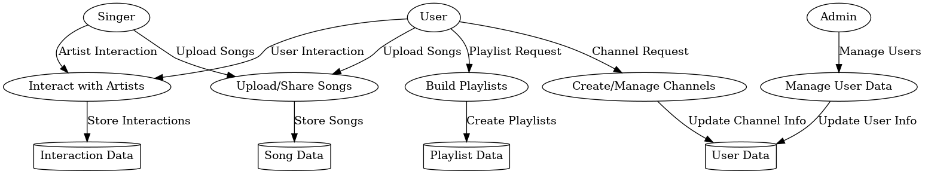

Figure 2 Data Flow Diagram

TuneFlix data flow shows how information is processed in the system. Some are creating channels, uploading songs, building playlists and most importantly by interacting with various artists. These processes manage and store data into certain specificities as the User Data, the Playlist Data, the Song Data, and Interaction Data. Users can upload songs and feedback, sing with others, and the Admin controls users’ information. Such DFD demonstrates how the data flows between external entities (users, singers, admin), processes, and data stores to monitor the effective and secure performance of the system.

## Development

The creation of the TuneFlix application was divided into a coded structure that implemented Java in the backend programming and Angular for the frontend. The backend was developed with the help of the Spring Boot that allowed creating applications quickly and use the microservices architecture. Hibernate as ORM for the best management of databases with the database engine of MySQL. For managing the details of the application, the frontend was implemented using Angular which gave an interactive view of playlist, channel, users, and artists. During Spring Security, it was significant that correct authentication and authorization measures were adopted to protect user information. Every feature including user management and song uploads were developed using modular and reusable code with a strong emphasis on following of coding standards to allow for the features to be scaled up and remain performant.

## Ethical Considerations

Ethical concerns have been important for TuneFlix project, and particularly, the project has focused on data protection, users’ safety, and their genuine consent. To enhance the security of the data provided by users, reliable authentication tools in the framework of Spring Security were employed. Such personal user details as well as any other information that is sensitive in nature, was encrypted before being stored. Besides that, the users were explained how their data would be used and asked to agree on every information they share. Security audits, as well as following GDPR and other data protection legislation, would ensure that the acquisition of users’ data accorded with all Feed Ethics necessary for secure processing, as observed by TuneFlix.

## Limitations

Nevertheless, applying the defined key features brought several challenges to TuneFlix application. Another main challenge was the time and resources that could not be devoted to more sophisticated user engagement analytics that, in turn, supplied additional information on users’ behavior. One of the drawbacks was the issues of the size of the application. Although Spring Boot and Hibernate provide relatively good scalability practical applications with millions of users may need additional steps to optimize the process and apply a load balancing technique. It is possible that future iterations might take such steps to introduce increased analytics depth and system architectural improvements for towering user traffic.

# Results and Discussion

As the final major step in the development of the TuneFlix music streaming application, a fully functional set of features that facilitate increased user engagement and improved communications between artists and users has been created. The last application was quite successful in the assimilation of significant features like Login/Logout, Account Creation, Playlist creation, Channel creation, and Singer creation. This chapter describes the outcomes of the web app creation and outlines how each of the components works in the graphical interface illustrated in the figures.

**Overview of the Home Page**

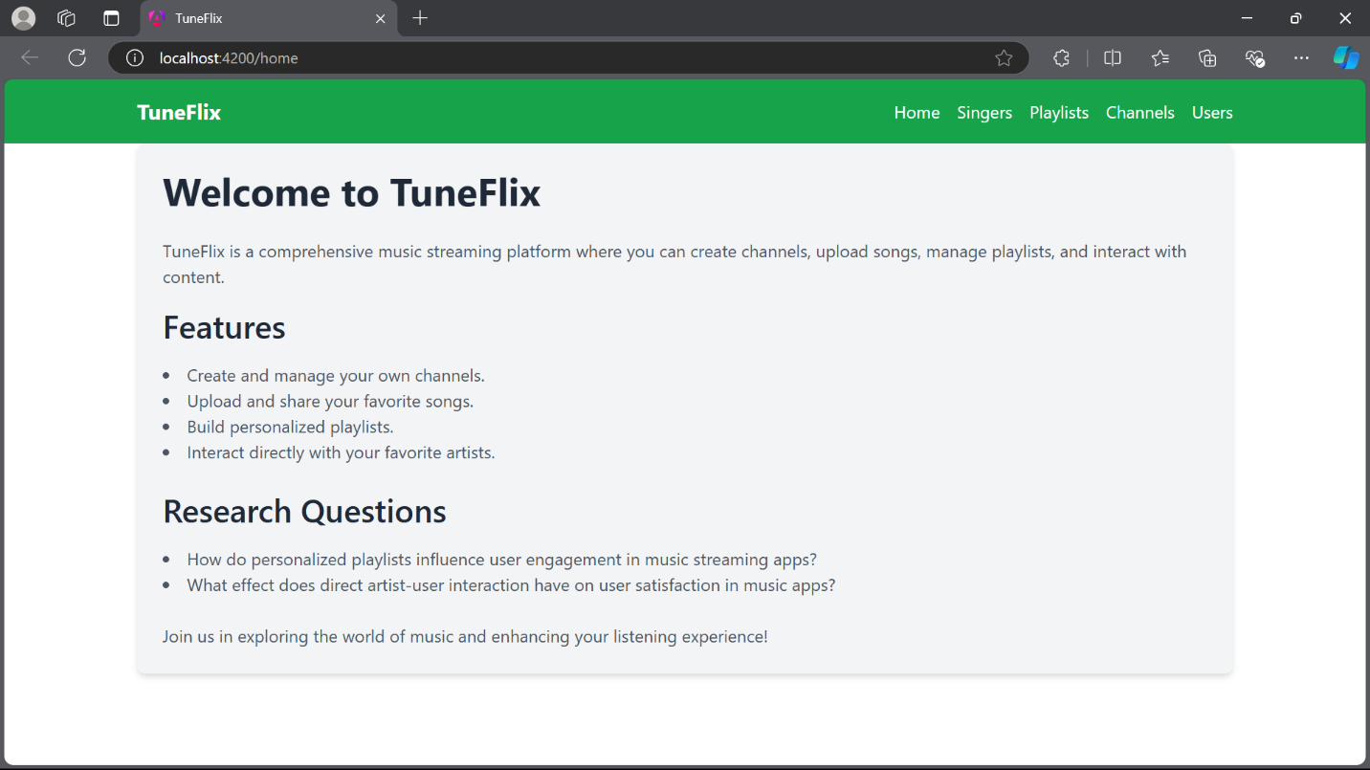

Figure 3 Home Page

The homepage of TuneFlix as can be seen in fig. 3 offers the user a brief and easy to understand information about the application and what it does. The page actually informs users and guides them on what the application entails; this include creating and managing channels, uploading and sharing songs, creating Playlist and directly communicating with favorite artists among others. This interface also helps in gaining an easy access and more over it directs the users to discover several other features of the platform. The basic web design also prevents the program from overwhelming the users through flashy interfaces or complex designing.

**Singer Management**

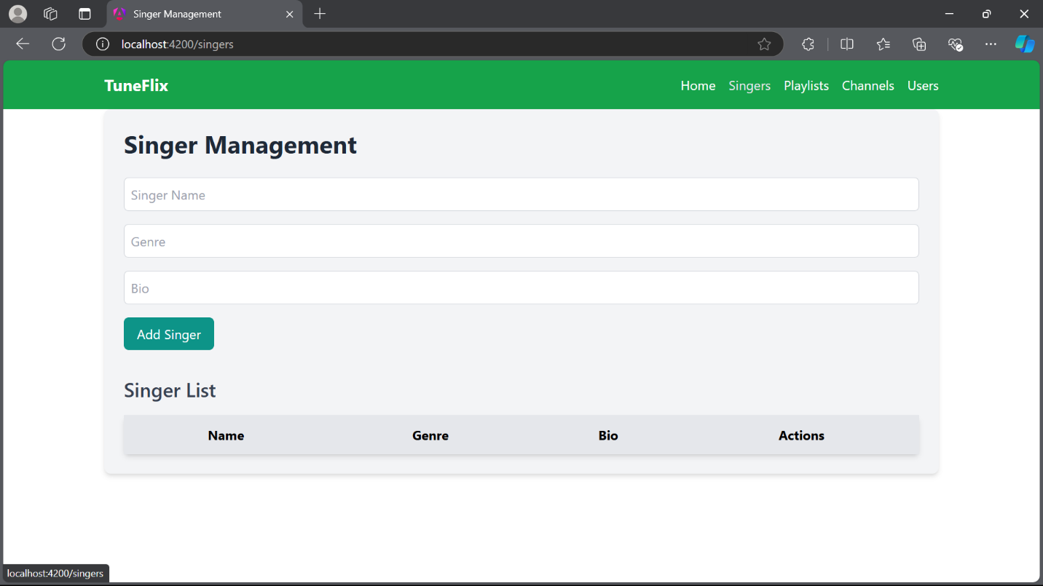

Figure 4 Singer Management

The Singer Management module (Fig. 4) is just one of the strands given that facilitation of relationship with artists is a core component of the software. This interface lets the admin to add other singers by entering the name of the singer, the genre, and, the biography. When a new singer has been introduced to the system, then the necessary information concerning the singer replaces the old one. This interface means that management of singers does not pose a problem and admins will be in a position to handle all the data in relation to the artists that provide content for the platform. This feature contributes towards the creation of necessary groundwork to implement a direct artist user interface whereby artists can sign up for accounts after which they can post their profiles to the users.

**Playlist Management**

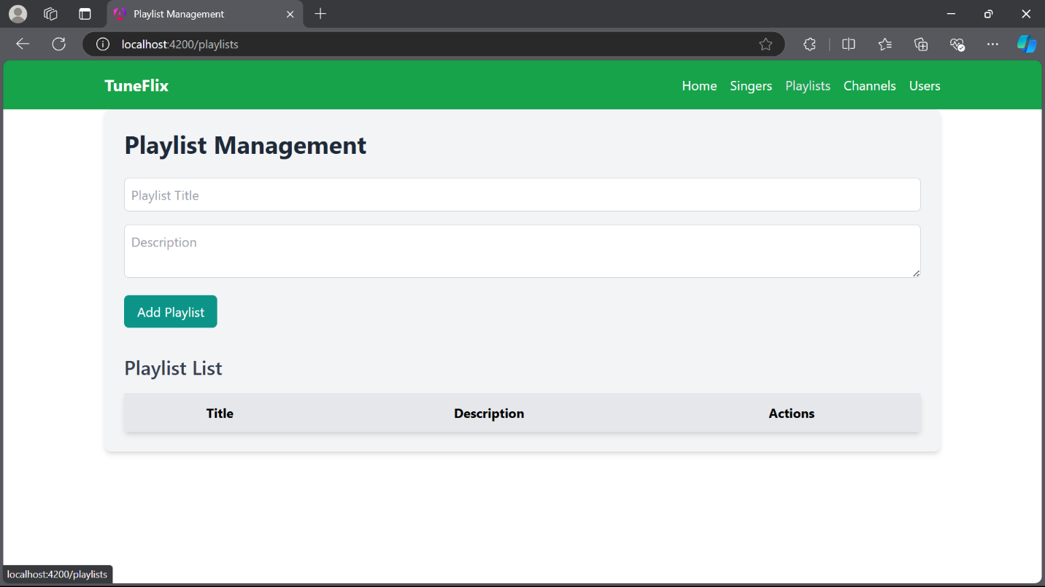

Figure 5 Playlist Management

The Playlist Management feature (Fig. 5) enables a user to generate and control his or her playlists or any other playlist. For instance, one can enter the title of the playlist and the description and place it into the library, as on the picture below. One of the many features that stand out with this Web application is the ability of the users to categorize the favorite tracks into playlists depending on the events. This is a major factor of TuneFlix recommended by this module since it improves user commitment via their favorite content. The playlist feature can be considered as unique compared with the recommendations provided within TuneFlix because the suggested plan allows users to diversify musical tastes and get only the most suitable songs.

**Channel Creation**

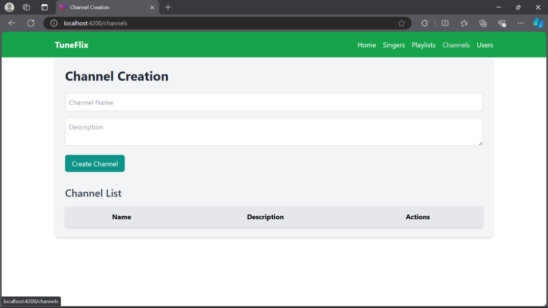

Figure 6 Channel Creation

The Channel Creation module is another feature of the web app that is illustrated in Fig. 6; users can create their own music channels by simply entering channel name and description. This feature is empowering because it allows the user to create specialization with the kind of music content they want to display, that is categorization. It appears that the platform enhances the prospects of sharing and curation of content through their respective channels, which enriches the prospect of the community arising out of music. Channel information can be accessed from the “Channel List” where extensive information of the created channels is found by users. The creative feature of TuneFlix lets users post their content within the website, and create dialogue regarding music and the musically inclined.

**User Management**

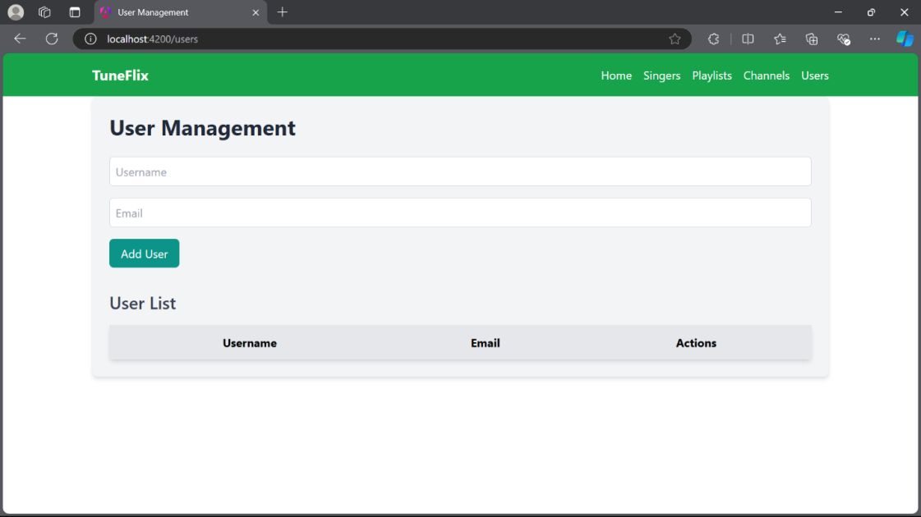

Figure 7 User Management

The User Management section (Fig. 7) gives administrators a way to administer the users of the system who chose to register on the platform. It represents that the admins can input usernames and email addresses and add new users shown in the interface. It also affords guarantee that the platform can expand the audience while at the same time keeping it very selected and secure. Managing the users is to a great extent critical for the sake of any fast-growing company that focuses on the distant and secure connections between the user base and artists. The admins can manage users to hold the integrity of the platform and to keep the app running smoothly and securely with using the User Management feature.

**Results Summary**

In summary, the development process of TuneFlix provides insight into the fact that all primary goals, which stand behind the construction of a streaming service targeting music fan base and their relationships with artists, was accomplished. Across the modules, the user interface is easy to use and serves its purpose of making it easy for users and admins to manage content, playlists, users profiles. From the technological point of view, Spring Boot, Hibernate, and Spring Security make the platform accurate, lightweight and secure, Angular ensures frontend responsiveness. The work of some of the modules, such as Singer Management and Playlist Creation, is closely related to boosting user engagement through the use of the Internet. Likewise, the Channel Creation feature plays a social aspect where users can share and equally select music further enhancing interaction and creation of a community for TuneFlix. The development ensured that these features blended well in the platform as a way of filling the existing voids in most of the current music streaming applications, especially in as much as artist- user interaction and other custom playlists.

## Discussion

The TuneFlix is the music streaming application that demonstrates a new level in the digital music due to focus on the audience, individual choice, and, the artist’s contact. Serving as a technological basis for Spring Boot, Hibernate and Spring Security, the platform adds features that put it into another league in its competitive field including Spotify and Apple Music. Functionality elements like Playlist Management, Channel Creation, Singer Management bring a more dynamic and user contributed content related environment where the user can create playlists, be in touch with the artists and become a part of innovative content. All these innovations meet the growing need for more personal and engaging music experience.

Another advantage of TuneFlix is that the freedom is granted to the users and the chance to choose and communicate with artists. One of the features that set TuneFlix apart from ‘traditional’ streaming services is that the users can participate in a very direct way in the ongoing framing of music listening through personalized playlists and sharing of channels. Singer Management module helps in real time interaction between artists and their customers which increases user interest level and develops better emotional relation with them. Nevertheless, the issue of impact and scalability, as well as data protection issues, are still seen. For the platform to operate seamlessly as it continues to expand, handling high traffic volumes, adapting to the changing laws on privacy will be necessary to retain user’s confidence.

In conclusion, it could be noted that TuneFlix carries really unique features and focuses highly on the customer in order to challenge the incumbents in the music streaming market. While scalability and data privacy remain long-term issues, evidence of the potentials of changing the ways users and artists interact seems promising. Overcoming these challenges we can identify the opportunities for TuneFlix in competition with other digital music streaming services.

# Conclusion

Thus, TuneFlix Music Streaming application has a huge potential to redesign the digital music consumption. In using the strategies of user involvement, individual approach and interaction with artists, TuneFlix can provide a noteworthy challenge to the other platforms in the sphere of music streaming. Features like custom playlist generation, customized channel creation, and direct artist to user conversations are some of the progressive features aiding a transition to more interactive Mysql environment that enables users to engage with both music and the artists at their own will and discretion. Due to the technical implementation of the application, based on Spring Boot, Hibernate, and Spring Security, the platform has a reliable and highly protective structure guaranteeing user’s fields safety.

The reason for the app’s success lies in the generally ‘bottom-up’ approach to the interface design which focuses on developing the tools that would enable its users to take charge of their musical choices and introduce these preferences to like-minded individuals. As such, TuneFlix differ from other streaming services that offer more limited ways for an artist to engage with a fan base. Incorporation of the ethic features prominently concerning data privacy and security for the users also adds considerable value to the application whilst providing it with the best chances of acquiring faithful users.

However, like any business venture, the development of TuneFlix has unique issues that may hamper growth and one of them is scalability and data privacy. Since the proposed platform will experience constantly expanding user base, the platform will have to be adjusted to the need of optimizing its functions and regulating the flow of the traffic of users without disturbing the usability of the platform. Moreover, new measures aimed at preserving user data and follow the same international legislation in the field of privacy will be necessary to preserve user trust and guard private information. Nevertheless, it is clear that TuneFlix has the potential to continue and to change the music streaming market to the best way, and, in general, the company has made a good start in this direction.

With the right strategies in place to address these challenges, TuneFlix could become a game-changer in the digital music landscape. Its innovative features that prioritize user interaction and engagement have the ability to set new standards for how music streaming platforms operate, especially as consumer demand for more personalized, interactive experiences continues to grow.

In conclusion, TuneFlix holds substantial promise as a music streaming platform that emphasizes user engagement, artist interaction, and personalization. By addressing key areas such as scalability, advanced analytics, social features, and global expansion, the platform can continue to grow and redefine the music streaming experience, setting new standards for both users and artists.

# Future Directions

Several directions where TuneFlix can develop further and expand abilities in the future to remain useful and helpful for its users we can discern: Also, invisibility and efficiency should be on the top of the list regarding application improvement. As it is now, TuneFlix offers a fairly reliable experience now, but as the user count and content providers increase this issue will need to be addressed. The new versions of the application should solve more complex problems in the load balancing, minimize the time needed for data queries in databases and consider cloud solutions for dealing with traffic intensity. Furthermore, the architecture of the application could be declared freer as to which of them will be used and in what way that would possibly allow the application to adjust to a larger amount of users unexpectedly coming in without the speed of the application decreasing.

Big data and enhanced reporting will also remain important in the future evolution of TuneFlix as well. The application of the machine learning and AI technologies allow for further” customization with additional user experiences on the sides of the platform. For example, AI algorithms might be used to improve the identification of tunes dependant on user habits, listening and social characteristics. Deep learning models may also be applied to identify content usage patterns and make relevant forecast of such trends and then the artists and the platform itself may devise means better suited to meet the users’ interest. Such enhancements would help give the user a better fit in terms of what they are looking for, and give them just what is of interest to them.

The next area of development is still also connected to the social and community spheres of the platform. Of course, as the concept of TuneFlix is progressing, enhancing the company’s interface with more social components may significantly influence the increased activity of users. Such features can easily be like the real time collaborative playlist or the live streaming and sharing of content on social platforms. Considering the overall idea of making the users engage more with each other, it will be possible to retain the audience on TuneFlix and promote the platform through people’s word of mouth influence. In the same regard, there is a possibility for the platform to incorporate methods of game mechanics, which would imply giving fun, for instance, for participating or sharing content, playlists or other community events as this would eventually improve the use of the platform among users.

The future of TuneFlix is also in I broadening the possibilities of artists’ interaction with their audiences. New features offered by the platform like Live streams, concerts, and exclusive content for Patreon, among other things make it easier for artists to generate revenue and also offer fans unique ways of engaging with their artists. These tools would also help artists to better interact with their fans, maybe turn those fans into more loyal users and prolong their stay on the platform. Artists could also benefit from analytics tools which could enable them see engagement of their works, to target special demographics, and market strategically.

Last but not least, with the globalization of TuneFlix, cultural adaptation or localization will be a useful factor towards TuneFlix’s growth. Among the suggestions there should be a multi-language support and regional content to make people from different cultures fell comfortable using the platform. Further, it should sustain relevance of the current regulation regimes of data privacy across the world consistently and securely. This will be especially so when the platform is launched in other regions that may have different legal regimes in terms of data protection and privacy.

# References

1. Bresciani, S., Huarng, K.-H., Malhotra, A., & Ferraris, A. (2021). Digital transformation as a springboard for product, process and business model innovation. *Journal of Business Research*, *128*, 204–210.
2. Camilleri, M. A., & Falzon, L. (2020). Understanding motivations to use online streaming services: integrating the technology acceptance model (TAM) and the uses and gratifications theory (UGT). *Spanish Journal of Marketing - ESIC*, *25*(2). <https://doi.org/10.1108/sjme-04-2020-0074>
3. de Quincey, E., & Mitchell, J. (2022). Card Sorting for User Experience Design. *Interacting with Computers*. <https://doi.org/10.1093/iwc/iwac002>
4. Dolata, U. (2020). *The digital transformation of the music industry. The second decade: From download to streaming*. Www.econstor.eu. <https://www.econstor.eu/handle/10419/225509>
5. Hesmondhalgh, D. (2020). Is Music Streaming Bad for musicians? Problems of Evidence and Argument. *New Media & Society*, *23*(12), 1–23. <https://doi.org/10.1177/1461444820953541>
6. Jansson, A. (2021). Beyond the platform: Music streaming as a site of logistical and symbolic struggle. *New Media & Society*, 146144482110363. <https://doi.org/10.1177/14614448211036356>
7. Knox, G., & Datta, H. (2020). Streaming Services and the Homogenization of Music Consumption. *Research.tilburguniversity.edu*. <https://research.tilburguniversity.edu/en/publications/streaming-services-and-the-homogenization-of-music-consumption>
8. M, A. T., Singh, S., Khan, S. J., Akram, M. U., & Chauhan, C. (2021). Just One More Episode : Exploring Consumer Motivations for Adoption of Streaming Services. *Asia Pacific Journal of Information Systems*, *31*(1), 17–42. <https://doi.org/10.14329/apjis.2021.31.1.17>
9. Moysis, L., Iliadis, L. A., Sotiroudis, S. P., Boursianis, A. D., Papadopoulou, M. S., Kokkinidis, K.-I. D., Volos, C., Sarigiannidis, P., Nikolaidis, S., & Goudos, S. K. (2023). Music Deep Learning: Deep Learning Methods for Music Signal Processing—A Review of the State-of-the-Art. *IEEE Access*, *11*, 17031–17052. <https://doi.org/10.1109/ACCESS.2023.3244620>
10. NG, D. T. K., NG, E. H. L., & CHU, S. K. W. (2021). Engaging students in creative music making with musical instrument application in an online flipped classroom. *Education and Information Technologies*. <https://doi.org/10.1007/s10639-021-10568-2>
11. Park, S. Y., & Kaneshiro, B. (2021). Social Music Curation That Works. *Proceedings of the ACM on Human-Computer Interaction*, *5*(CSCW1), 1–27. <https://doi.org/10.1145/3449191>
12. Prey, R. (2020). Locating Power in Platformization: Music Streaming Playlists and Curatorial Power. *Social Media + Society*, *6*(2), 1–11. <https://doi.org/10.1177/2056305120933291>
13. Rizki Bagaswara Putra, & Setiawan, B. (2022). Selection Platform Music Service Cloud with Simple Multi-Attribute Rating Technique – User Service Application (SMART ALP). *Journal of Applied Science, Engineering, Technology, and Education*, *4*(1), 115–132. <https://doi.org/10.35877/454ri.asci849>
14. Saarikko, T., Westergren, U. H., & Blomquist, T. (2020). Digital transformation: Five Recommendations for the Digitally Conscious Firm. *Business Horizons*, *63*(6), 825–839. Sciencedirect. <https://doi.org/10.1016/j.bushor.2020.07.005>
15. Singh, S., Singh, N., Kalinić, Z., & Liébana-Cabanillas, F. J. (2021). Assessing determinants influencing continued use of live streaming services: An extended perceived value theory of streaming addiction. *Expert Systems with Applications*, *168*, 114241. <https://doi.org/10.1016/j.eswa.2020.114241>
16. Skutle, M. (2022, May 20). *Discovering music in the streaming era: How online recommendation engines and application design influence users’ habits and discoveries in online music streaming services*. Bora.uib.no. <https://bora.uib.no/bora-xmlui/handle/11250/2998199>
17. Spilker, H. S., & Colbjørnsen, T. (2020). The Dimensions of streaming: toward a Typology of an Evolving Concept. *Media, Culture & Society*, *42*(7-8), 1210–1225. <https://doi.org/10.1177/0163443720904587>
18. Wang, Y., Han, L., Qian, Q., Xia, J., & Li, J. (2021). Personalized Recommendation via Multi-dimensional Meta-paths Temporal Graph Probabilistic Spreading. *Information Processing & Management*, *59*(1), 102787–102787. <https://doi.org/10.1016/j.ipm.2021.102787>
19. Weinberger, M., & Bouhnik, D. (2020). Various information aspects following the emergence of music streaming applications. *Online Information Review*, *45*(1), 118–137. <https://doi.org/10.1108/oir-04-2020-0118>